TCS HACKQUEST CTF
Challenge Name: Area 64
Flag Format: HQX{...}
The challenge presented an encoded string and hinted that it was not a hash, encouraging identification of the correct encoding method rather than attempting to crack it.
Objective : To correctly identify the encoding used in the given text and decode it to reveal the hidden message and flag.

Initial Observation
The provided string appeared as:
WW91J3JlIGluc2lkZSBBcmVhIDY0LiBIZXJlJ3MgeW91ciBrZXkgOiBIUVh7NzBjNWQ1MjVjYTliYTEzY2Y5MjQ4MGE0OWJmNGNjZjh9
At first glance, the string might resemble a hash. However, closer inspection revealed important characteristics that suggested otherwise.

Identifying Base64 Encoding
The following indicators confirmed that the text was Base64-encoded:
- Contains only valid Base64 characters:
  - Uppercase letters (A–Z)
  - Lowercase letters (a–z)
  - Numbers (0–9)
  - Special characters (+, /, =)
- No fixed-length hexadecimal pattern (unlike MD5/SHA hashes)
- Clean padding and structure typical of Base64
- Commonly used in beginner CTF challenges to hide readable text
These observations ruled out hashing and pointed clearly toward Base64 encoding.

Decoding the String
Method 1: Using Kali Linux
echo "WW91J3JlIGluc2lkZSBBcmVhIDY0LiBIZXJlJ3MgeW91ciBrZXkgOiBIUVh7NzBjNWQ1MjVjYTliYTEzY2Y5MjQ4MGE0OWJmNGNjZjh9" | base64 -d
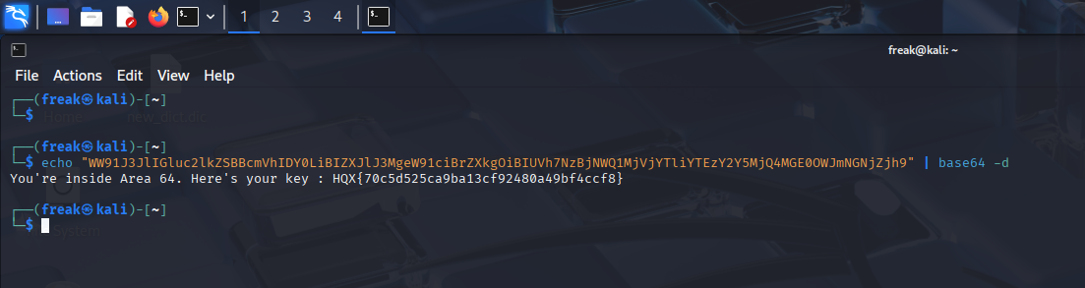

Method 2: Using online cracking tools or websites
Like I used www.base64decode.org/
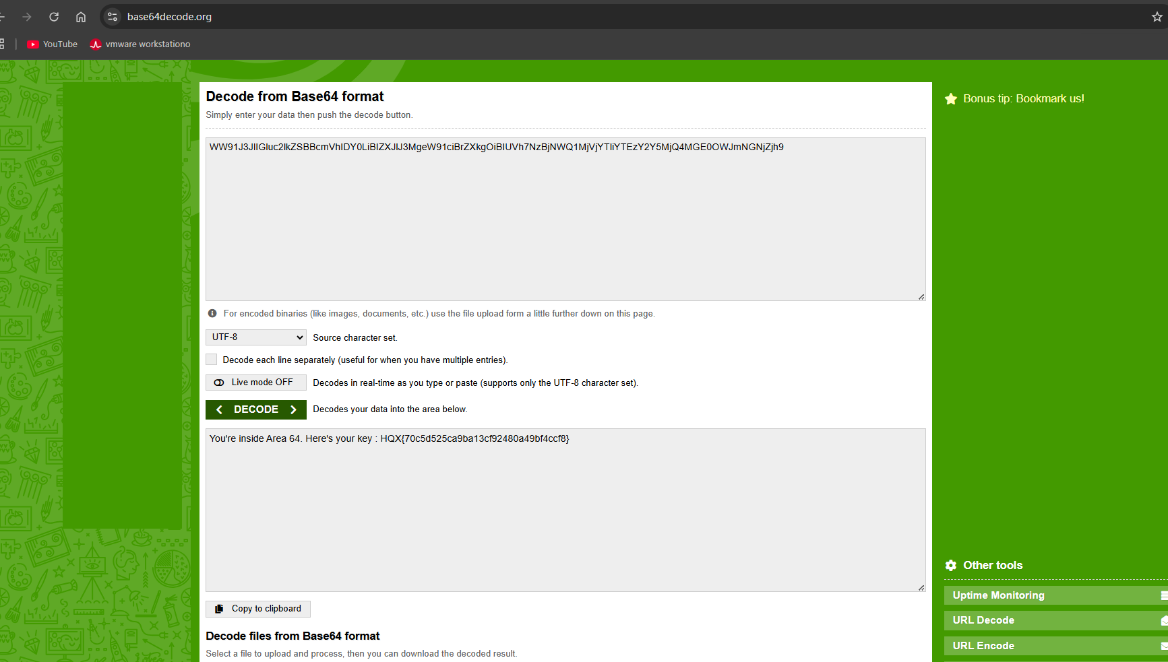
Flag Obtained
HQX{70c5d525ca9ba13cf92480a49bf4ccf8}

